WEB DEVELOPMENT
WEDE5020
MOEGAMAD SA-EED BROWN
ST10517784
GROUP 1

CONTENTS
Organisation Overview….pg3
Website Goals....pg3
Current Website Analysis.…pg4
Website Features and Functionality….pg4
Design and Users Experience….pg5 -pg6
Technical Requirements….pg6
Time and Milestones….pg7
Budget….pg7
References….pg8

- Organisation Overview

Idi Delites is a small bakery business that began as a home-based operation, baking goods for people in the local community. It’s similar to another business known as Bakers Creationz, which began also as a home kitchen business and expanded through the support of customers.

MISSION STATEMNT:
- To produce high quality baked products, while being able to deliver excellent customer service and meeting customer needs by being creative and consistent.

TARGET AUDIENCE:
- Are those who have a sweet tooth for baked products such as cake and other sweet treats.

2)Website Goals and Objectives

Main Objective is to create an online presence and improve communication with customers.

GOALS:
- To display products
- Allow online enquiries
- Attract more customers
KPI’S:
- Website Visitors
- Enquiry submission
- Increase in orders

3)Current Website Analysis

STRENGTHS:
- Clear navigation menu
- Functional enquiry form
- Easy layout to understand

WEAKNESSES
- Basic Design
- No mobile responsiveness

IMPROVEMENTS:
To use consistent branding, improving styling and make the site mobile-friendly

4)Website Features and Functionality

- Home page: consist of business introduction
- About us: History and mission of business
- Product page: Cakes, pastries, desserts
- Contact Page: Phone Email, Location
- Enquiry Page: Customer form

5)Design and User Experience

The bakery has a warm feeling due to the rich chocolate browns paired with a creamy background, and as well with the soft pinks for accents. These colors work together to highlight the sweet treats. The two browns handle structure (header, footer, buttons) while the pinks add a feminine, sweet touch for interactive elements which makes it feel more welcoming.
Primary color- The two browns are used mostly through out to the design to show the overall tone.
secondary color- is the cream to make the pictures and everything else stand out
accent color – Rose pink and as well soft pink

USERS EXPERINCE:
- Easy navigation
- Clean layout
- Warm inviting colours
- Mobile-friendly design

:

Wire-frame:
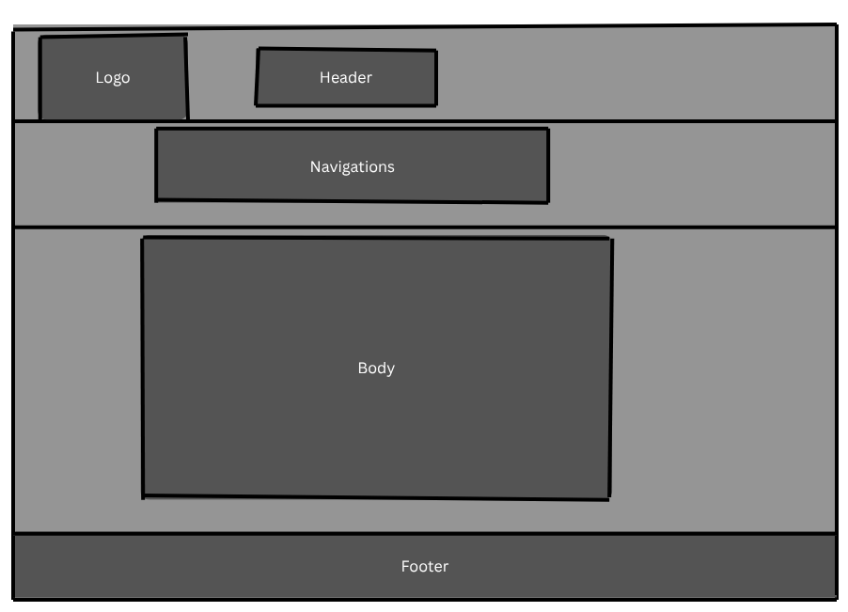

6)Technical Requirements

- Hosting packages
- Domain: www.ididelites.co.za
- HTML, CSS and Java

7)Time and Milestones

- Week 1: Research
- Week 2: HTML structure pages (Due 20 April 2026)
- Week 3: Apply ccs styling to improve colour layouts and more design (Due 29 May 2026)
- May/ June/ July: Adding java script features

8)Budget
Gant Chart

Budget Items | Start Date | End Date | Duration | Cost | Timeline
Domian Registration | May 2026 | July 2026 | 1 day | R150
Hosting Payment | May 2026 | July 2026 | 12 Months |  | R500
Website Maintenance | May 2026 | July 2026 | 12 Months |  | R200

9)References

- SME South Africa (2023). Bakers Creationz: Baking Dreams into Reality: https://smesouthafrica.co.za/bakers-creationz-baking-dreams-into-reality/
- Georges Bakery: https://gbco.co.za/our%20story/ , took inspiration from their about
- The Sweet Sliced Bakery: https://www.thesweetslicebakery.co.za/our-story took inspiration from their about
- Ai generating Logo: https://www.design.com/s/logo?var=ai-logo-generator-dcom&code=25OFFSEM&utm_medium=cpc&utm_source=google&utm_campaign=africa_generic_logo_ai_max&utm_adgroup=logos&utm_content=769431353646&utm_keyword=logo+generator&utm_network=g&gad_source=1&gad_campaignid=20838923220&gbraid=0AAAAADwF9LBoKFdc-X6AxDo--sC3ljZsd&gclid=CjwKCAjwtIfPBhAzEiwAv9RTJlpZ-XA8hWL3QYObRUZWOcgt_O-sfVwkRlA0zSjPDpWoRatnkY-_uBoCjcAQAvD_BwE, used to create the Idi Delights Logo
- Took inspiration form other business from Tok Tik and Instagram

Research and sourcing
Research was conducted on Idi Delites to identify possible content for each page of the websites, such as using YouTube to understand what must be in each page.
Such as information gathered on social media platforms such as Tik Tok and Instagram for bakery trends, customer reviews and product ideas. Used Unsplashed, Flat Icon and Google Fonts for inspiration as a public resource. Including using Ai generator for my logo and designing it on my own by removing certain features of the logo to make it my own.
Original contents would be the website with its products, description, pricing and business history.

